Nicholas Sammut

CSC 425 – Mobile Computing

Dr. Mark Allison

Homework 3

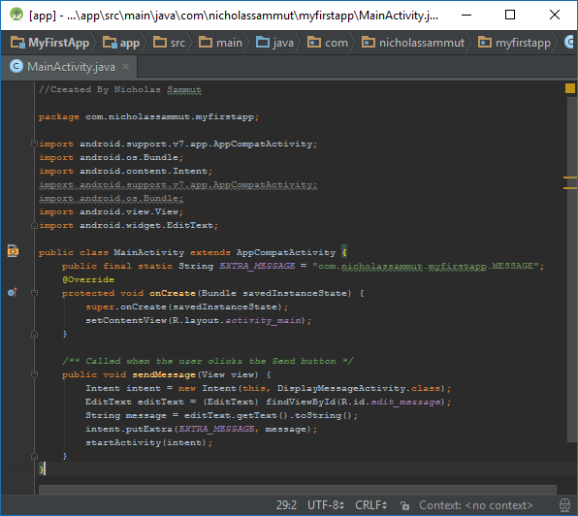

MainActivity.java

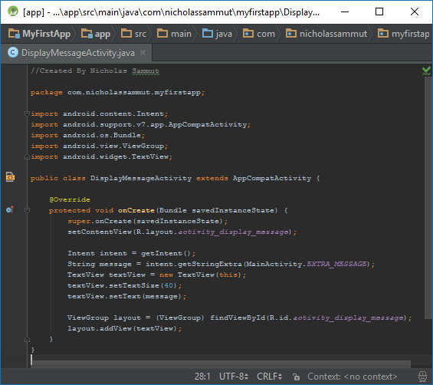

DisplayMessageActivity.java

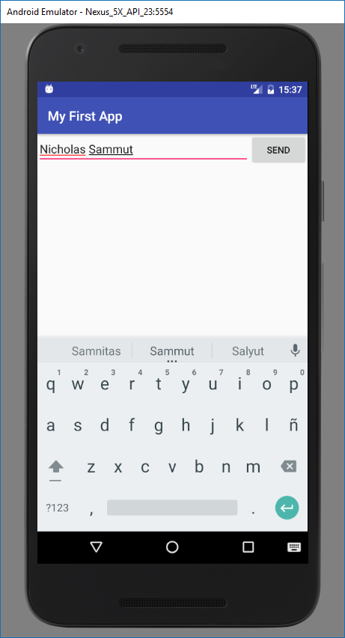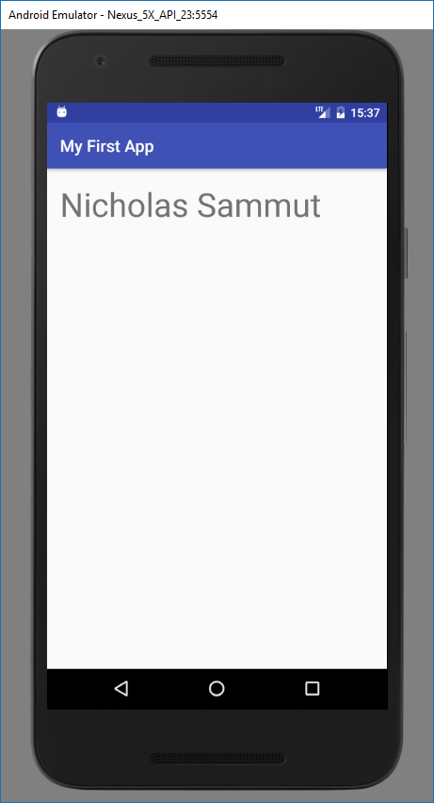

Screenshots of Activity